**Training date generation**

For this part, we used python liberary PIL, numpy, opencv, and os.

Our original data source is downloaded from Pascal 2. All the pictures are in .jpg format.

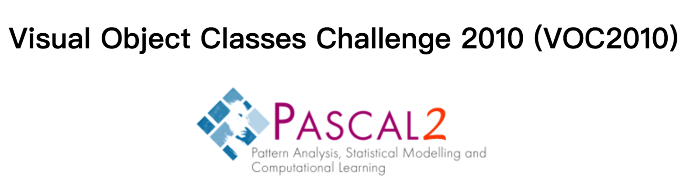

We then operate on the original pictures from pascal 2 to make our own usable training data. Our purpose is to make 1000 pictures, each are partly blurred, along with corresponding matrices (represented in form of 2D-list in python) that indicates where are the blurred parts in each picture.

To make such qualified images. We did:

1. make a blurred copy of the original image:

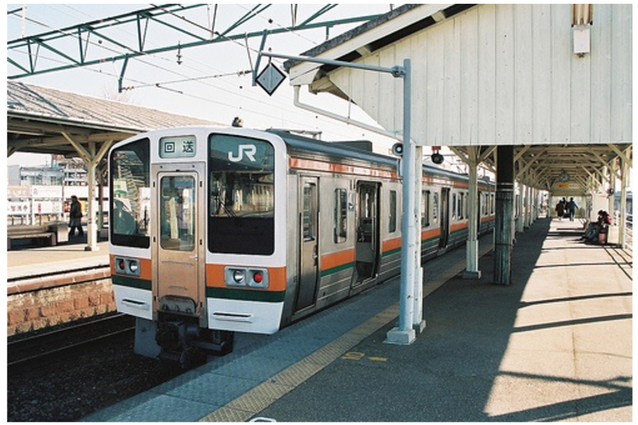 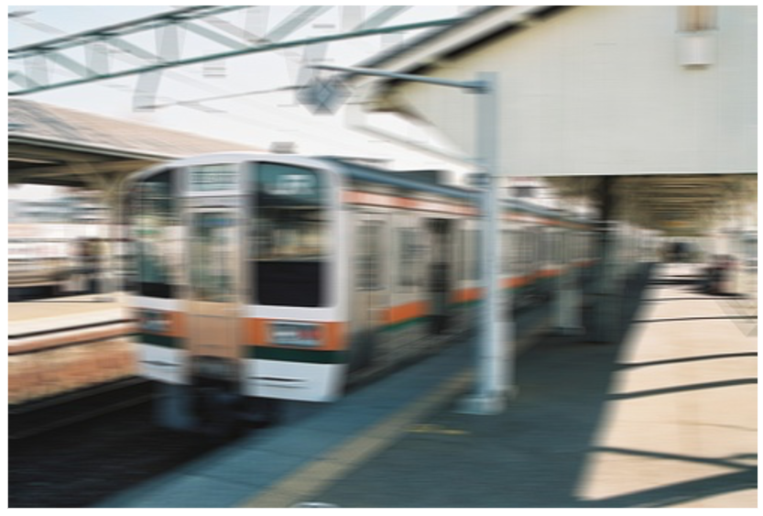

Original Blurred

1. Cut both original and blurred copy in to small pieces of 30*30. Like the picture below.

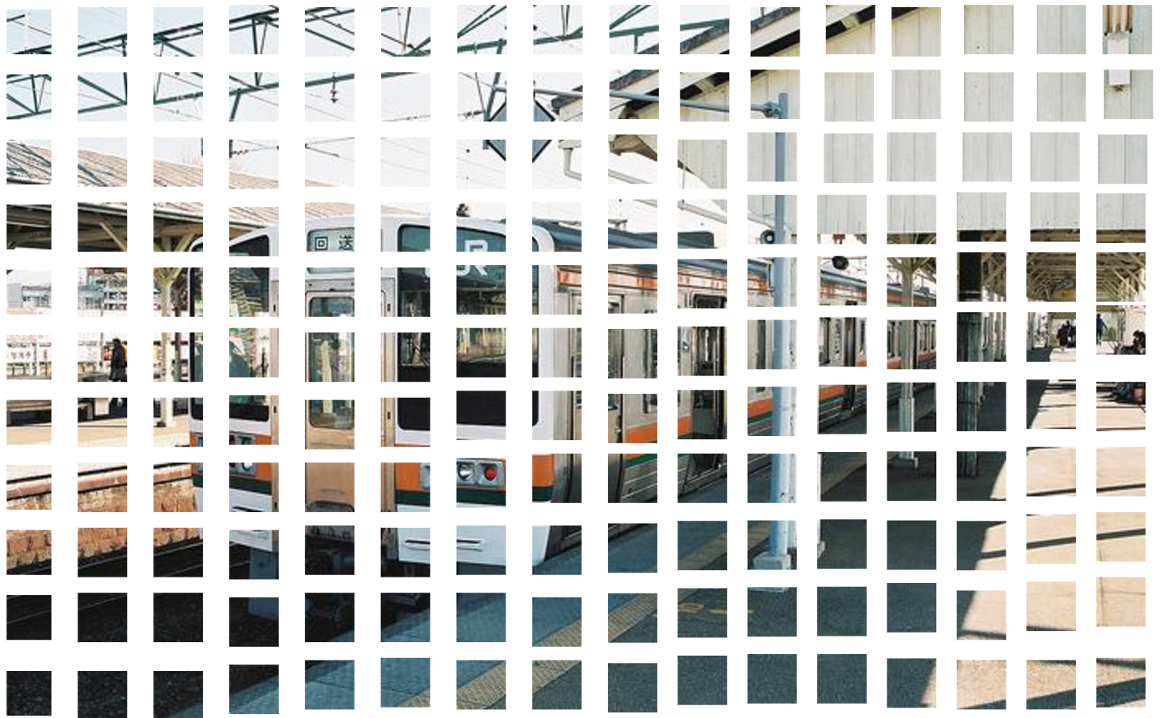

Creating a 2-D list of size of the picture’s size divided by 30. Therefore, we got a matrix that each number in it represents a cut pieces. We set all the numbers to 0 since they are all not being blurred yet

1. Randomly picking half of the cut pieces and using the blurred version to replace the original version. Then we change the number that represents this piece to 1.

rangex = sizex/30

rangey = sizey/30

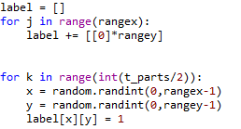

Therefore we got our single qualified image and its corresponding matrix:

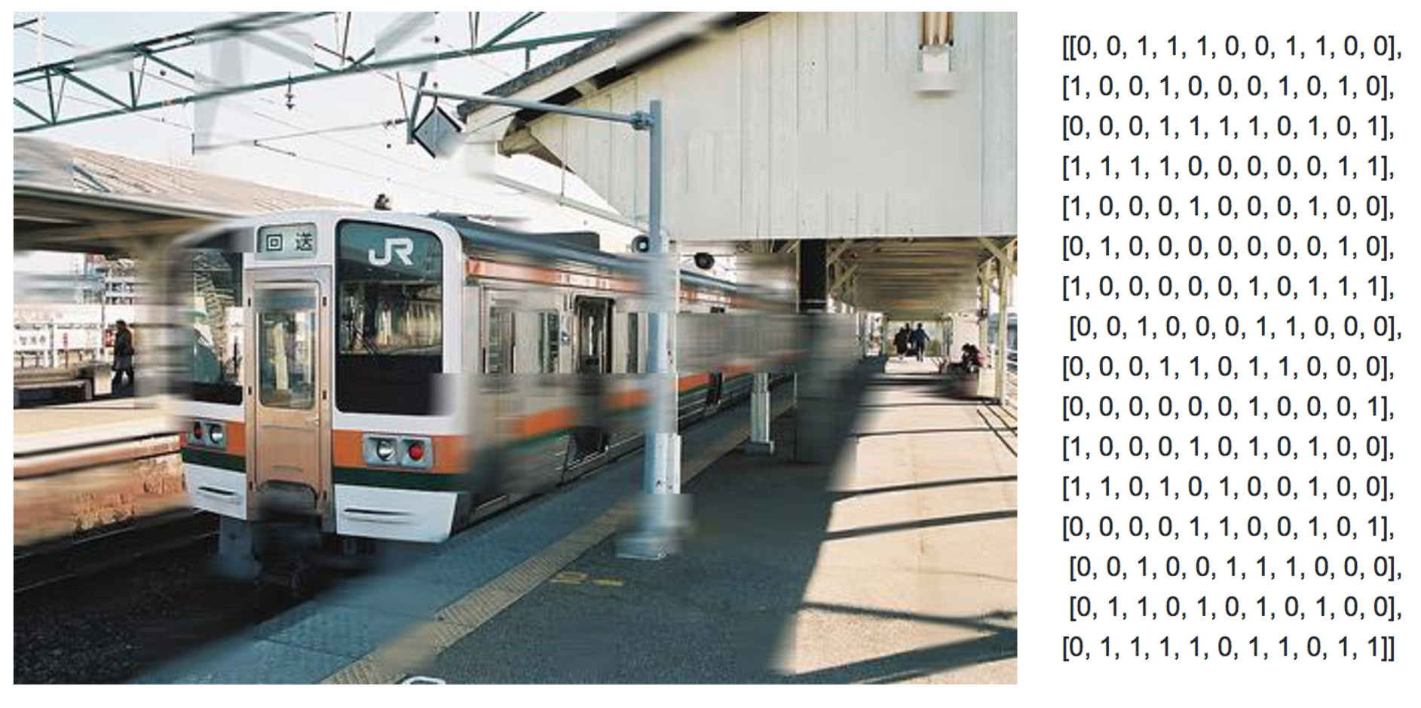

1. Save the image in names of “n.jpg” where n is the serie number of the image. Then add the matrix to a list to form a 3D- list “labels” that contains matrices of all the images.
2. Repeat the operation above for each image. We would have a folder that contains partly blurred images named from 0.jpg to 10000.jpg and also a 3D-list Labels that contains 1000 matrice.

For example. If an image is saved as 23.jpg. Then its corresponding matrix can be find at “labels[23]”